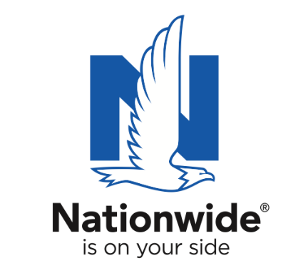
FOR IMMEDIATE RELEASE

April 22 2024
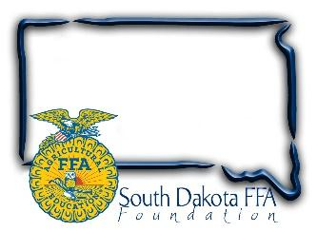
Contact:
Gerri Ann Eide
gerri@sdffafoundation.org
605-765-4865

Photos of Recipients and Winner: https://drive.google.com/drive/folders/1dLtwLc683KJrVTpOjgvo41iyySitdQ0Z?usp=sharing

SD Teacher Named “Ag Educator of the Year”

Harrsiburg’s Tara Fastert honored as South Dakota’s Golden Owl Award®
2023-2024 grand prize winner

Brookings, SD – As the need grows for more ag educators across the nation, the ag teachers who go above and beyond in educating America’s youth and future leaders are more important than ever. In South Dakota, eight exceptional ag teachers were recently named as finalists of the 2023-2024 Golden Owl Award® for their positive impact in the classroom and communities they serve. Of the finalists, Tara Fastert, an agricultural teacher at Harrisburg, was named South Dakota’s grand prize winner and 2023-2024 Ag Educator of the Year.

Nationwide, in partnership with the South Dakota FFA Foundation recognized Fastert as the Golden Owl Award grand prize winner during the South Dakota FFA State Convention. In addition to the title of South Dakota Ag Educator of the Year, Fastert will receive the coveted Golden Owl Award trophy and a $3,000 Nationwide-funded donation to further Harrisburg’s agricultural education efforts.

In her nomination, one of Ms. Fastert’s students shared, “She is an inspiration both inside and outside of the classroom, striving to push every student out of the box to help them grow throughout their high school career. Most importantly, she lets their students fail and helps them see that failure isn’t final – but guides her students to learn through failures, and cares about each student that walks through the classroom door.”

Reflecting on her classroom leadership, Fastert shared, “You must give respect to get respect from students. I always treat students with respect; I am open and honest and treat them like adults. My classroom is also a safe space. My students know they can come to me for advice, and I will give them an honest answer. This is why students are in the ag department from 7 am until 4 pm (or later) every day. I am proud of the environment I have created, and happy students feel comfortable spending so much time here. Having students nominate me shows how much I mean to them and how much they care about me. They would not take the time to write such nice things if I was not making a difference in their lives.”

As the number one insurer of farms and ranches in the U.S.¹, Nationwide established the Golden Owl Award with its state partners to shed light on the contributions of South Dakotas leading agricultural teachers and provide additional resources to support their programs.

“Nationwide is proud to recognize the dedicated teachers who are educating and inspiring students to pursue careers in agriculture,” said Brad Liggett, president of Agribusiness at Nationwide. “We’re honored to have the opportunity to appreciate their contributions, highlight the growing need for their services, and supply additional resources to help provide their students with optimal learning experiences.”

Nationwide supports the future of the ag community through meaningful sponsorships of national and local organizations. In conjunction with the Golden Owl Award, Nationwide is donating $5,000 to each participating state’s FFA, including the SD FFA, to further support the personal and professional growth of students, teachers and advisors alike.

For more information, visit www.goldenowlaward.com.

Photo: Nationwide representative Darrin Hinze presented the State Ag Ed Teacher of the year to Tara, Fastert, Harrisburg.

Photo2: Nationwide representative Darrin Hinze with finalists (back): Clayton Sorum, Tea Area, Brady Duxbury, Wessington Springs, Austin Bishop, Belle Fourche, Joshua Johnson, Brookings. (front): Fred Zenk, Webster, Tara Fastert, Harrisburg, Renae Gebhart, Lemmon, and Terry Rieckman, McCook Central. :
¹ Source: A.M. Best Market Share Report 2022
About SD FFA
The SD FFA has 6143 members in 110 high school agriculture education programs. The SD FFA Foundation is proud to support Agricultural Education and the FFA's mission to make a difference in the lives of students by developing their potential for premier leadership, personal growth and career success through agricultural education. For more information about the South Dakota FFA Foundation and South Dakota's FFA programs, visit www.sdffafoundation.org or follow us on Facebook.
About Nationwide
Nationwide, a Fortune 100 company based in Columbus, Ohio, is one of the largest and strongest diversified insurance and financial services organizations in the United States. Nationwide is rated A+ by both A.M. Best and Standard & Poor’s. An industry leader in driving customer-focused innovation, Nationwide provides a full range of insurance and financial services products including auto, business, homeowners, farm and life insurance; public and private sector retirement plans, annuities, mutual funds and ETFs; excess & surplus, specialty and surety; pet, motorcycle and boat insurance. For more information, visit www.nationwide.com. Follow us on Facebook and Twitter.
Nationwide, the Nationwide N and Eagle, Nationwide is on your side and Nationwide Retirement Institute are service marks of Nationwide Mutual Insurance Company. © 2023 Nationwide.

